Video Quality Assesment for Concurrent Multipath Transfer

M.Saravanan / AP
Computer Science and Engineering
AVS College of Technology,
Salem, India
smilesrana@gmail.com
Dr.S.Nithya Kalyani / ASP
Computer Science and Engineering
K.S.R College of Engineering,
Tiruchengode, India

Abstract— The visual quality of images and videos is typically assessed by human experts and yields mean opinion scores (MOS). To reduce cost and time, providing methods for automated image/video quality assessment (IQA/VQA) is desirable for the multimedia and signal processing community at large. Current VQA methods are designed solely to capture aspects of the technical quality of displayed video streams. In addition to such visual quality we aim at methods to characterize images and videos in terms of other perceptual aspects. These aspects include the number and magnitude of eye movements required for viewing the content, the viewer's appreciation of the use of color, and the degree of interestingness. Several such components together with visual quality are combined for an overall ration of perceptual quality. Moreover, by investigating the human perceptual process and by understanding psychophysical phenomena, a saliency model will be developed that is based on a Markov model of eye movements.
Additionally, we will bring the state-of-the art a step closer to reality by setting up and applying media databases of authentic distortions and diverse content, which stand in contrast to current scientific data sets containing only a small variety of content and 'artificial' distortions. Given an image or video whose visual quality is to be assessed, the question arises as to which IQA/VQA algorithm should be applied. Instead of choosing an algorithm based on a fixed test database, it can be assumed that a better quality assessment is possible when choosing an algorithm based on a particular test database consisting only of images/videos similar to the query image/video.
Keywords—Video Streaming; Concurrent multipath transfer; Stream Control Transfer Protocol; Video Quality Assessment;

Introduction
Video quality assessment (VQA) is crucial for the optimization of several video processing applications, such as restoration, reproduction, enhancement, compression and acquisition. Considering the increasing growth in consumption of multimedia content and the relevance of QoE for video platform services (like Youtube or Netflix - as it can decide the success or fail of these platforms), the scientific community has devoted particular attention to this area, developing objective metrics that automatically evaluate the quality of the video, trying to model the subjective analysis of humans.
Basically, the evaluation of video quality is divided into two classes: subjective methods, where human viewers measure the quality of the video and rate them on a subjective scale; or objective methods, that can predict the subjective evaluation by using algorithms to simulate the human visual system behavior. Subjective methods are more precise since it directly expresses the feeling of the user about the quality of the delivered content, but it is time and resource-consuming, making them not suitable for practical applications. On the other hand, objective methods are applied without human participation, allowing real-time applications. For objective metrics, three approaches are considered 1: Full-Reference (FR) approach, where the distorted sequence is compared to the reference sequence; Reduced-Reference (RR), where a limited feature of the reference sequence is used to measure video quality and No-Reference (NR), which can predict subjective video quality without the reference sequence.
In the past few years, researchers developed several objective metrics that simulates human visual system (HVS) considering characteristics that are more correlated with the human vision perception. With this proposal, the Structural Similarity Index (SSIM) was introduced by Wang et al.2 , considering the high capability of HVS to extract structural information from the frames of the video. It is considered one of the best recent objective metrics and it is widely used in practice due to its good performance and low complexity

CONCURRENT MULTIPATH TRANSFER

Model of CMT
On a multi-homed host there are multiple paths for transmission, but only one path is used for transmitting the data at a time. In the case of SCTP multi-homing, the remaining paths come into existence if the primary path is failed. The concept of Concurrent Multipath Transmission (CMT) has evolved by exploiting the main feature of backup path in SCTP multi-homing. This technique uses the available network interfaces for transmission by pooling multiple paths together. It allows the data to transmit over multiple connections like 3G, 4G, Ethernet and Wi-Fi at once. We observe this technique being implemented in some of the mobile devices where the connection to the internet is continuously maintained and used in an efficient way. This helps to increase the Quality of Service (QoS) and user experience as well. In CMT, the data stream is divided and transmitted in parallel paths concurrently using various scheduling schemes. The basic CMT model can be depicted from Figure 1-1.
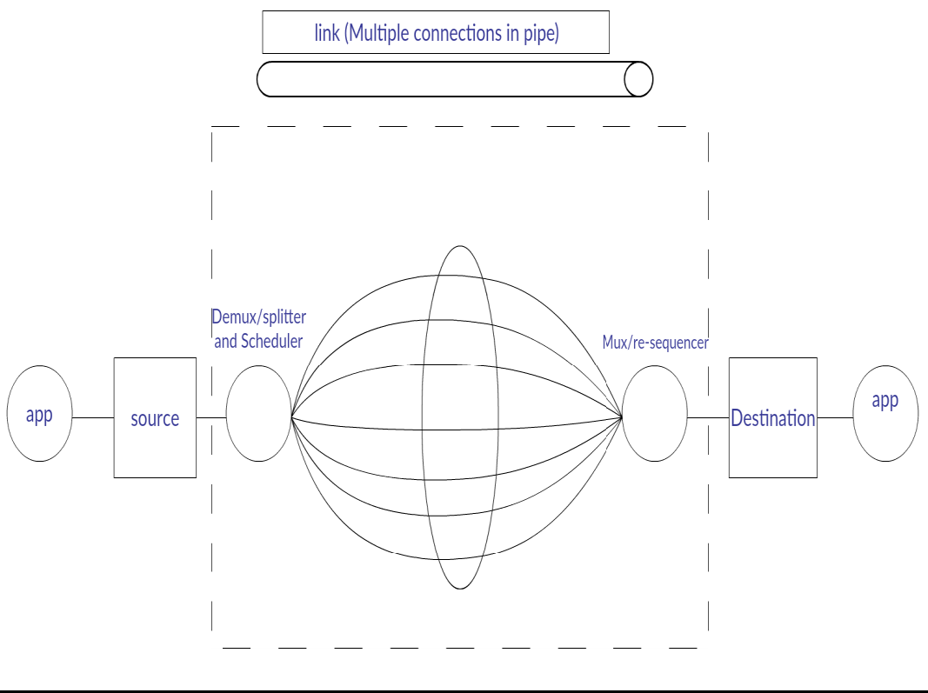
Figure 1-1: Basic Model of CMT
The concept of multi-homing brought a drastic architectural change in non-multi-homed networks. Initially in CMT all the available active interfaces are pooled together in order to select multiple paths for concurrent data transmission. In CMT, the use of parallel transmissions is similar to the principle of P2P content distributed systems i.e. multi-source download. The peer which requests the transmission service selects the best paths that gives highest combined throughput. This whole process of transmission is called as Concurrent Multipath Transfer. CMT mechanism combines multiple overlay paths into one virtual high capacity pipe. The concept of CMT is to make use of the available multiple paths concurrently which is not supported by the current communication stack. In order to transmit a data sequence concurrently over available paths it should be divided accordingly. This mechanism is known as Stripping. After stripping the data, there should be a scheduling mechanism to transmit the chunks of data over available paths.

Stripping Mechanism
Ingress router selects the paths which form the virtual pipe out of all the available paths. The data stream is divided into segments which are split into ‘m’ parts. They are transmitted to the destination host via ‘m’ parallel paths.
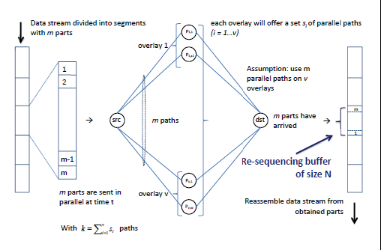
Due to stochastically varying delay present in the paths, the parts of data can arrive out-of-order at the receiver router which degrades the performance of the application. In order to minimize this, the receiving router maintains a finite re-sequencing buffer. But, when the re-sequencing buffer is full and there are packets yet to arrive then packet loss may occur which also degrades the application performance and is undesirable. Usage of re-sequencing buffer also increases the waiting time and hence end-to-end delay.

CMT Scheduling
Assumption of infinite receiving buffer is not always realistic, especially in smartphones with limited memory. When multiple paths have different path characteristics, overall throughput may be reduced due to the slowest path in the transmission. Therefore for limited buffering, data need to be transmitted reliably and in sequential order to a destination. A scheduling algorithm is to be used because it plays a crucial role when performance characteristics vary in different paths. The main responsibility of the scheduler is to pair packets in the send buffer with proper destination addresses so that reordering at the receiver is minimized. Some of the scheduling algorithms are described below:
- Naive Round Robin
The naive round robin scheduling is a simple mechanism. Whenever there is space in the receiving buffer of a particular destination, the packet from send buffer is assigned and passed to the network layer for transmission. When multiple destination addresses have space in their respective receiving buffers, packets at the send queue are assigned in a round robin fashion each time to another destination address. In this mechanism, there is no priority given. Due to this, the aggregated performance decreases because of the disparity in the path characteristics which leads to situation where no destination can deliver packets faster than the slowest path irrespective of delay.
- Weighted Round Robin (WRR)
The weighted round-robin scheduling mechanism is based on priorities. The main concept of WRR is to efficiently utilize the paths which offers more bandwidth and are economic for transmission. This scheduling mechanism creates the possibilities for data transmission modelling. Each path is assigned with a pre-defined weight according to the priorities before the transmission. During the transmission, packets are divided and transferred based on the weights specified. Therefore more packets are sent on the high priority paths than the less priority paths.
- Bandwidth aware Scheduler (BAS)
Naive scheduling doesn’t use any intelligence. Hence, re-ordering becomes difficult. BAS was developed in order to mitigate the problems created by naive round robin scheduler. BAS assigns packets to the best destination address. When a packet arrives at the send queue, BAS places it in a virtual send queue after assigning a destination address to it. Whenever there is space in the receiving buffer of the destination address, the packet with the lowest sequence number is retrieved from the virtual send queue and is passed to the network layer for transmission. Scheduling decisions are made based on the bandwidth estimates and the volume of the packets to be delivered for each destination address. When a packet arrives at the send queue, BAS calculates the reception index of a destination address. Reception index combines a destination’s load which is given by the number of scheduled packets with its capacity which is the rate of delivery. In this way, sender can make immediate decisions and the packet is assigned to the destination address with the lowest reception index.
- On-demand scheduler (ODS)
In BAS even before there is space in the receiving buffer of the destination address, scheduling decisions are made whereas in on-demand scheduling destination is selected first and then the packet is chosen. ODS lists the available destination addresses using Estimated Time of Acknowledgement, ETA. After computing ETA of all the destination addresses, ODS discovers the destination address which has earliest ETA and also an open CWND. Then ODS searches the send queue for the packet which has the least sequence number so that there will be no need for re-ordering later.
- Out-of-order scheduling for In-order arriving in CMT (OSIA)
In a general CMT, when packets are transmitted from sender, the packets on the slowest path will not arrive on time at the receiver and hence packet re-ordering is required. To ensure that the packets arrive in-order the sending sequence can be adjusted such that packets on the slowest path are sent earlier while the ones on the faster path are sent later. OSIA disorders the original packet sequence. The packets which are ready to transmit are out-of-order. Delays on the paths are estimated and OSIA partitions the flow into several chunks. Then the packets in each chunk are assigned using probabilistic scheduling and are transmitted on parallel paths. OSIA scheduling scheme consists of two steps:
- a) A splitting step, based on flow level stripping
- b) A probabilistic assigning step, based on packet level scheduling

Proposed Approach
To evaluate the performance of CMT in real-time by modelling different mechanisms involved. The protocols which support CMT are under development and they have less support for modelling. So the current real-time implementation model is designed without using the existing protocols and it also support modelling of the system. The experimental model implemented in this thesis, clearly presents the usage of off-the-shelf components (i.e. utilizing the basic available functionalities). This model supports the main functionalities like data fragmentation at source, data re-ordering at destination, different scheduling mechanisms for transmission.
The model designed for implementing CMT can be validated by recognizing the concurrent transmission of data. The performance values obtained by varying the total number of TCP connections in transmission shows that the throughput is less influenced. But by observing the trend lines under both RRB and WRRB scheduling mechanisms, it can be concluded that the throughput decreases as the total number of connections increases in the transmission. The reasons behind this decreasing trend-lines include network overhead, load on network interface and increase in complexity.
The performance results may be varied in a live streaming scenario due to the continuous splitting and re-arranging of data at client and server respectively. Although this thesis evaluates Round-Robin and Weighted Round-Robin scheduling mechanisms, there are several other mechanisms. They need to be implemented and evaluated on the real-time setup. Some other performance parameters like delay distributions, jitter etc., which can also be measured and evaluated. In detailed statistical analysis can be performed as it is out-of-scope in this work. In this work, the network components used are of same type at the source and this can be modified by using different wireless networks from different service providers. The single-homed destination used for implementation can be replaced by a multi-homed destination, which might bring more challenges in real-time.

CONCLUSIONS
The results obtained by varying number of paths in transmission shows that there is a significant impact on throughput.
The results are categorized under different cases based on the number of paths and type of interfaces used for transmission. From the obtained performance values it can be concluded that as the number of efficient paths increases the throughput also increases.
By observing the values obtained in different cases, they clearly present the impact due to variation in path characteristics. These results also help to conclude that CMT as a transmission mechanism has high transmission rates than general transport protocols.

References
- J. Iyengar, K. Shah, P. Amer, and R. Stewart, "Concurrent Multipath Transfer Using SCTP Multihoming," in SPECTS 2004, San Jose, California, July 2004.
- J. Iyengar, P. Amer, and R. Stewart, "Retransmission Policies For Concurrent Multipath Transfer Using SCTP Multihoming," in ICON 2004, Singapore, Nov. 2004.
- S. Shakkottai, R. Srikant, A. Broido, and k. claffy, "The RTT Distribution of TCP Flows in the Internet and its Impact on TCP-based Flow Control," Tech. Rep., Cooperative Association for Internet Data Analysis (CAIDA), Feb. 2004.
- J. Iyengar, P. Amer, and R. Stewart, "Receive Buffer Management For Concurrent Multipath Transport Using SCTP Multihoming," Tech Report TR2005-10, CIS Dept, University of Delaware, Jan. 2005.
- R. Stewart "Stream control transmission protocol (SCTP)" 2007.
- 15. J. R. Iyengar P. Amer R. Stewart "Concurrent multipath transfer using SCTP multihoming over independent end-to-end paths" <em>IEEE/ACM Trans. Netw.</em> vol. 14 no. 5 pp. 951-964 Oct. 2006.

